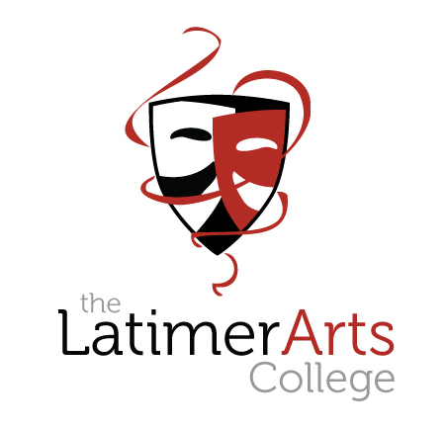

ARTS APTITUDE

APPLICATION PACK 2021

Please return to The Latimer Arts College
no later than 9.00 am on Monday 5 October 2020

Applications received after this date will not be accepted

Welcome to our Arts Curriculum

Students enjoy an outstanding arts curriculum at The Latimer Arts College delivered by specialist staff who are passionate about the value that the arts add to a child’s personal development. Through the arts, our students grow into confident and creative young adults, with strong and effective communication and collaborative skills.

In Key Stage 3, all students have weekly lessons in Art, Dance, Drama and Music where an exciting range of themes, genres and techniques are explored. This is enhanced by vibrant extra-curricular opportunities offered through weekly clubs to performances and shows, both at the College and in the local community.

At Key Stages 4 and 5, students can choose to specialise in one discipline or study for qualifications in a range of arts subjects.

Our students have the advantage of being able to study and perform in our Masque Theatre, where they also learn about the technical aspects of delivering a performance in our Dance and Drama studios and they are able to access purpose built, specialist art and design classrooms.

We are proud of our arts curriculum and the outstanding reputation that we have.

If your child shares our passion and commitment, we would love to consider them for one of our arts places.

Applications for September 2021

Guidance notes

This application form is linked to the Local Authority admissions criteria that have been agreed with the Governing Body of The Latimer Arts College, for intake at Year 7 for September 2021.

It will be used as the basis for decision making by The Latimer Arts College which then informs the Local Authority.

Contact may be made by the College with the primary school and other external organisations solely for the purposes of verifying information provided by parent(s)/carer(s).

The procedure is as follows.

- Parent(s)/carer(s) download an Arts Aptitude Application Pack from the College website.

- Parent(s)/carer(s) complete the Arts Aptitude application form and submit it to the College by 9.00 am on Monday 5 October.

- Shortlisted applicants will then be invited to submit a short audition video to be received by the College no later than 3.00 pm on Friday 16 October.

- Parent(s)/carer(s) will be notified by the College if their child has shown an aptitude for the Arts in a letter that will be sent by Friday 23 October. This will not be an offer of a place, but an indication as to whether an applicant has an aptitude.

The Latimer Arts College operation of the admission criteria for Arts Places – September 2021 entry

Following the allocation of places to students who have an Education, Health and Care (EHC) Plan, which names the school as appropriate provision, when there are more applications for places than there are places available, priority will be given in the following order:

1. Children in public care (looked after children) or previously looked after.

2. Students who will have an older brother or sister continuing at The Latimer Arts College at the time of admission of the younger child.

3. Children of staff where that member of staff has been employed at the College on a permanent contract for two or more years at the time at which the application for admission to the College is made, and/or the member of staff is recruited to fill a vacant post for which there is a demonstrable skill shortage in the area.

4. 20 students will be selected for their aptitude in art, dance, drama or music. To be selected through an online video audition process.

- Those students who live with their parents or carers at an address in Barton Seagrave or the linked town/villages of Burton Latimer, Cranford and Isham (using wards as according to Kettering Borough Council).

- Other students.

Operation of the Arts Places Criteria

Parent(s)/carer(s) complete both the Local Authority application form and the Arts Aptitude application form if applying for an ‘Arts Aptitude' place (20 places).

During October contact will be made with parent(s)/carer(s) of Arts Aptitude applicants selected on the basis of their application form. Shortlisted applicants will then be invited to submit an audition video to be received by the College no later than 3.00 pm on Friday 16 October.

Candidates can apply to audition for up to 2 disciplines.

Final selection will occur after the audition panel has considered all of the submissions.

Details for Online Audition Submission

We understand that sending in a video entry is a hugely different way of undertaking the workshops we have traditionally held; we have adjusted our process to comply with COVID health and safety guidance.

We will ask successful shortlisted applicants to send in their audition submission as follows:

- Successful applicants will be sent a brief with instructions to prepare their audition piece for each art form along with instructions on how to upload this.
- At the start of the recording, we ask the student to state their name, date of birth and the title of their submission.
- Students should then record their chosen piece in response to the given brief.
- The video length should be no longer than 3 minutes.

These videos will be used for audition purposes only and will only be viewed by the audition panel. To comply with GDPR the College will permanently delete all the videos by 31 August 2020.

Should any candidate not be able to provide their audition by recorded means, the College will liaise with parents and carers to agree an alternative process for reviewing a performance.

Please complete the application form in as much detail as possible stating how your son or daughter will benefit from attending an Arts College or how they have demonstrated an aptitude for the arts.

Arts Aptitude Places for September 2021
Application Form

Name of Student: |  |  |  |  |  | Gender:
Primary School:

Home Address:

Parent(s)/Carer(s) Name:

Mobile Telephone Number: |  |  |  | Email Address:
Art Disciplines to be submitted (if successful) – please tick up to 2.

Art |  | Dance |  |  | Drama |  |  | Music

Please state how your son or daughter will benefit from being a member of an Arts College.

You may want to consider:

Which arts area/s they are particularly interested in and why
- What their contribution to the arts has been to date
- What their most significant achievement in the arts has been
- What their future aspirations may be

Please write no more than 500 words.

Parent(s)/Carer(s) Signature:

Please return this form to The Latimer Arts College marking it ‘Arts Aptitude Application’, as soon as possible, but no later than 9.00 am on Monday 5 October 2020

