Full name of Latimer
School Address
School telephone number
Name of the Principal
School starts at
School finishes at
The web address is:
How long will it take you to get to Latimer?
What time will you have to leave home?
Moving Up- Transition Workbook
Welcoming our new year 7 students to Latimer 2020
Name: Form:

Draw a self portrait here:
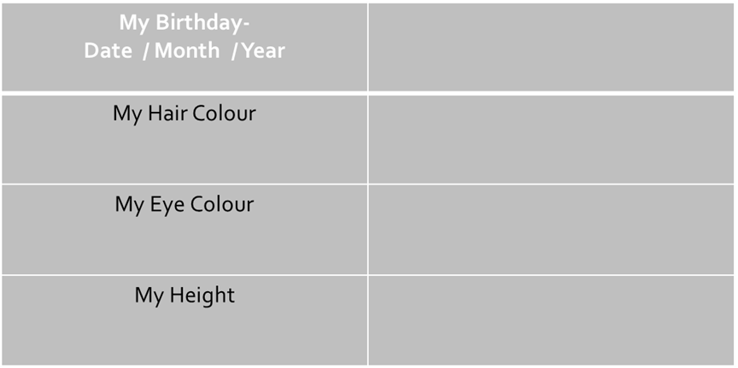

‘All about Me’

1 | Do you have any brothers or sisters at Latimer who will still be in College in September? If so, what year will they be in?
2 | What is your favourite sport(s)? You can choose more than one.
3 | Name a favourite dessert and describe why it is so good.
4 | Name a favourite type of food, e.g. Indian, Mexican. Anything in particular?
5 | What is the best song you have ever danced to? Tell us about it…
6 | What kind of music do you like? Any particular solo artist or band?

7 | What talents do you have, e.g. juggling or singing?
8 | What is your most embarrassing moment?
9 | What is your favourite place to holiday? Tell us a few reasons why.
10 | What is your favourite TV programme and why?
Relating to ‘Lockdown and COVID 19 2020’
11 | What is your best memory of experiencing lockdown 2020?
12 | What has been something you would change if we had to experience lockdown ever again?
13 | If you could advise your pre lockdown self, what would you say or do?

- List 3 things you are most excited about moving to Latimer

- List 3 things you are a little worried/nervous about joining Latimer

- List 3 things you would like to know more about Latimer

- List 3 things that will help you when moving to Latimer

Maths, Design, English, Science, Geography, History, Art, Music. PE, Humanities, RS, French, Assembly, Tutor time, LORIC, Drama, Dance, ICT.

D | A | N | C | E | H | M | G | E | O | H | I | M | J | E | E | A
F | M | A | M | W | S | L | U | S | M | I | S | E | T | T | I | S
R | U | D | A | N | C | E | Z | S | A | C | P | N | U | H | A | E
A | F | G | T | R | D | P | W | R | I | I | A | G | T | I | N | P
H | S | R | H | P | G | R | T | E | N | C | I | T | O | C | A | O
J | T | A | S | L | U | B | N | Y | R | A | N | E | R | S | S | L
H | U | B | J | E | I | C | Q | L | E | R | M | X | T | A | S | S
E | U | A | U | H | E | M | U | A | H | S | U | D | I | N | E | H
N | F | M | L | G | E | O | G | R | A | P | H | Y | M | D | M | C
G | I | M | A | V | M | A | I | T | Y | E | O | A | E | M | B | N
L | O | N | I | N | O | T | O | H | R | T | T | S | C | O | L | E
I | P | G | E | E | I | G | R | D | U | O | E | R | A | R | Y | R
S | P | I | F | O | S | T | E | K | R | M | P | T | T | A | E | F
H | I | S | T | O | R | Y | I | C | S | A | S | M | E | L | R | A
E | N | E | V | E | P | I | F | E | N | O | M | U | R | S | B | K
J | K | D | S | L | O | R | I | C | S | C | N | A | R | P | U | M
Y | Z | X | T | L | S | V | Z | T | T | I | C | T | A | L | P | O

Times of Day | Monday | Tuesday | Wednesday | Thursday | Friday
Period 1  08:30-09:30 | Maths  TU Ma1 | English  EFS En6 | Science  DR Sc3 | RS  NC Hu7 | DT Food  ES Dt1
Period 2  09:30-10:30 | Design  SW Dt5 | French  AP Mfl 2 | Music  CJE Mu1 | Drama  JMM Masque | English  EFS En6
BREAK -
10:30-10:50
Period 3  10:50- 11.50 | English  EFS En6 | History  KM Hu4 | Maths  TU Ma1 | French  AP Mfl 2 | History  KM Hu4
Tutor Time / Assembly  11:50-12:15 | TUTOR TIME (ASSEMBLY) | TUTOR TIME | TUTOR TIME | TUTOR TIME | TUTOR TIME
LUNCH
12:15-13:00
Period 4  13:00-14:00 | PE  TM S Hall | Art  ES Ar3 | French  AP Mfl 2 | ICT  CJT It3 | Geography  SPT HU2
Period 5  14:00-15:00 | Science  DR Sc3 | Maths  TU Ma1 | Dance  CK2 Da1 | Design  SW Dt5 | Science  SS Sc 1
Extra-Curricular opportunities available ranging from sports to the arts.
‘Aspire’ homework club is available to complete homework in the Learning Resource Centre (LRC)

- What lesson do you have at 09:30 on Monday?.................................
- What are the initials of your Geography teacher? ………………………..
- How many minutes does each lesson last? …………………………………
- How long is Tutor Time? …………………………………………………………..
- How long is lunch and break combined? …………………………………....
- What day could your house assembly be? …………………………………..
- How many times a week could you have the following:
  - Maths: ………………………………..
  - English: ……………………………….
  - History: ……………………………….
- Which days will you need your PE kit?………………………………………………………………………………………
- Who is your English teacher? …………………………………………………..
- What day do you have assembly?.....................................................

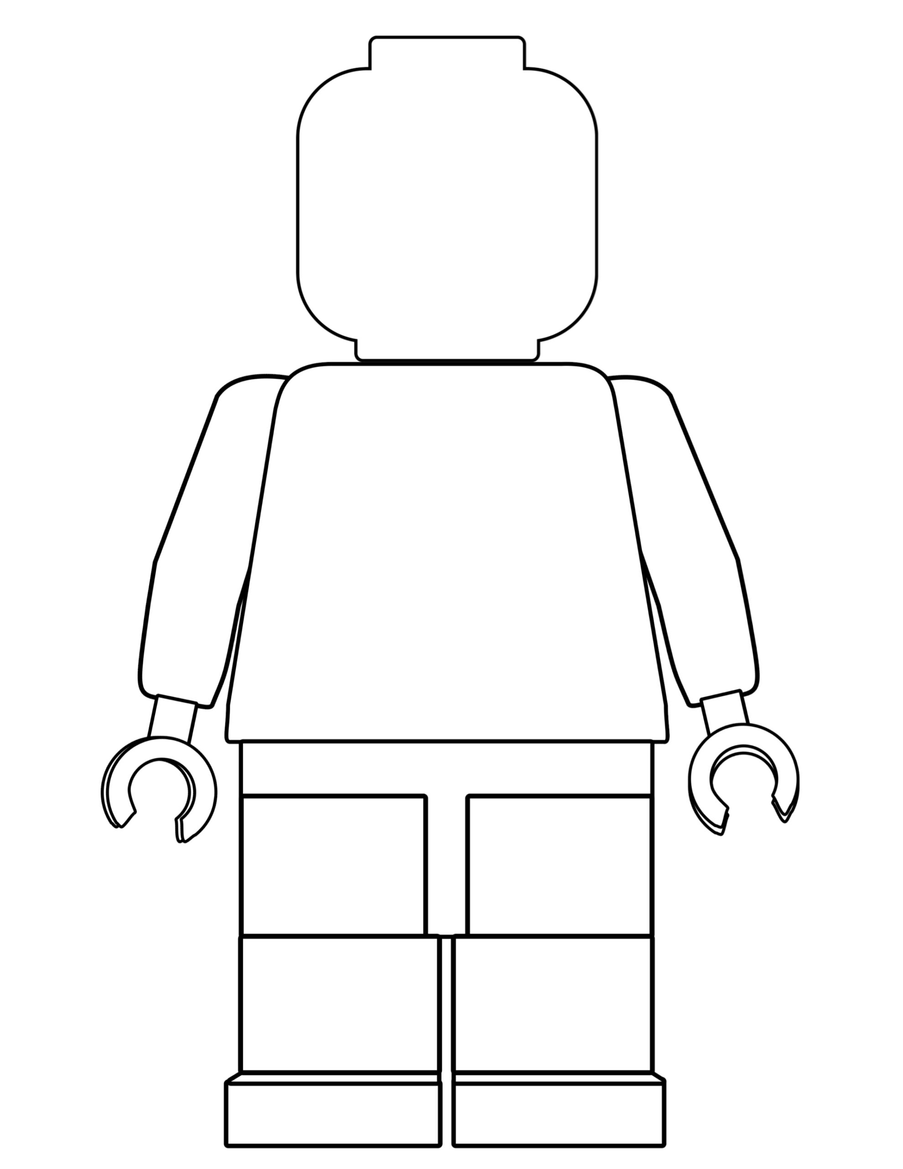

Develop my creative writing fully using my imagination | Know 5 phrases in another language | Represent your school in a national competition
Learn to play a musical instrument | Volunteer in the local community | Learn as many countries in the world as you can
Play an instrument performing for Latimer | Know all of the counties in England | Have a dream to do something amazing in the world
Learn how to manage my money | Taste food or drink from another country | Develop and build up my resilience
Cook a new meal from scratch | Read a more challenging book | Become more confident when talking to adults
Make new friends from other schools | Raise money for charity | Reduce my screen time on mobile devices
Take up a new sport and develop the skill | Join an after school club each term | Learn to dance a particular style
Use a computer to create your own website | Learn the periodic table off by heart | Set up a YT channel

