Home Learning Booklet

15th -19th June

Home Learning Booklet

Firstly, we would like to THANK YOU for your CONTINUED hard work, we know that this is difficult for you and your family. The point of these task is to practice your skills and to keep you engaged.

This week will see you complete the second set of tasks to complete over the next 6 weeks, which will form an overall project.

Again, we need to remind you please not to worry about school work. We will ensure that you catch up on anything that you need to once you return to school. Everyone in the country is in the same position as you – and at the moment the most important thing is looking after your mental well-being.

That is why the activities are slightly different from “normal” school lessons: some of them can be worked on when you are completing your daily exercise; some of them can be done with family and friends.

All of them are designed to help you think about learning and develop skills, rather than specific knowledge.

NEW THIS WEEK!

Last week we included work from White Rose Maths which is set depending upon your year group. This week we ask you to sign up to Tassomai, a science app which will allow you to access science work at year 7 or year 8. There are some detailed instructions to set up this week.

We would like you once you have set it up to try and do 10 minutes a day – which will be almost an hour a week of science. You will find instructions on how to do this on the attached powerpoint, or if you go on to show my homework you will also find instructions there as well!

And remember that for those of you who want a different style of work than the booklet we are suggesting that you could use the following website for different subjects

https://www.thenational.academy/online-classroom/subjects/#subjects

Simply click on the link and select your year group. Then select your subject and follow the lesson plan.
You should use this booklet as a menu of activities that you choose to complete.

We are suggesting you complete up to 5 individual activities a day.

Spend no more than an hour on each!

If you have brothers and sisters in Years 7 or 8 you might want to work on them
together to complete them.

What activities do you need to complete?

English

English has provided you with a choice of activities to complete. However, as well as completing these, you should be reading as much as possible.

Research has proven that a key indicator of future success is the extent of vocabulary that a student has. We want you to use this time at home to read regularly and increase that vocabulary.

If you have a book that is linked to Accelerated Reader and can continue to quiz, then that is even better! We will ensure you are rewarded for your efforts. You can find out if your book (even if it is not from the LRC) has an AR quiz by entering some simple details here: www.arbookfind.co.uk

Alternatively, both Kindle and Audible are currently giving free trials of their sites – please speak to your parents and carers before signing up to these.

Maths

Maths have provided you with a range of activities to complete. One of these is to complete Corbett 5 A Day which should be done each day to help improve basic numeracy skills. This week we have also included different work books for different year groups to work on.

Science

From this week as well as the Science project if you can please do 10 minutes of Tassomai a day.

Personal Development (PDP)

You will have one PDP activity per week which will be set via SMHW at the start of the week.

Department Activities

You should try and complete at least one task from each area, (English, Maths, Science, Art & Design, BIM, Humanities, MFL, Performing Arts, PE), although you might want to do more. Some of the activities have a challenge element, which you might also want to do.

How to access additional resources

If you need any additional documents this will be indicated on the department pages. If you log into your school account and then click the links they should take you to the documents.

To access College files at home and to share resources that teachers have created, students can use the Home Access Plus website https://hap.latimer.org.uk/HAP/myfiles/

Alternatively, any documents you need are saved in the W drive in the folder “Year 7-9 home learning”.

Planning your time

Below is a blank timetable again. Your first job is to plan out your week and pick the activities that you want to do. You will then create your own personal timetable! However, some of you requested a little more guidance so there is also a guidance timetable for you if you are in Year 7 and 8. If you are in Year 9 you should look at your option subjects.

Remember to put in time for reading and one Corbett 5 A Day.

 | Monday  15th June | Tuesday  16th June | Wednesday  17th June | Thursday  18th June | Friday  19th June
1 | Plan your week
2
3
4
5

However, some of you did not like having to plan your own time so a suggested timetable is below. This is a suggestion only.

 | Monday  15th June | Tuesday  16th June | Wednesday  17th June | Thursday  18th June | Friday  19th June
1 | Corbett Maths and Reading  Tassomai | Corbett Maths and Reading and Tassomai | Corbett Maths and Reading and Tassomai | Corbett Maths and Reading and Tassomai | Corbett Maths and Reading and Tassomai
2 | Humanities (1) | BIM (1) | Art and Design (1) | PE (1) | Performing Arts (1)
3 | Science (1) | English (1) | Maths (1) | MFL/Ignite (1) | PSHE task
4 | Performing Arts (2) | PE (2) | BIM (2) | Humanities (2) | Art and Design (2)
5 | English (2) | Maths (2) | Free Choice | Free Choice | Free Choice

English Faculty

Remember to keep reading regularly as well as completing the activities below

Choice of tasks:
Please choose from the following list of tasks. They have been chosen to give you a choice of learning activities.
‘The Olympic Stadium – Descriptive Writing – Option One’
Write a description of an Olympics athletic arena as suggested by the picture below.
- Choose four parts of the picture that you want to make the focal points of your description, then draw boxes around them. S
- Zoom in one on of the boxes. Compile lists of nouns, adjectives, verbs and adverbs to describe what is going on in the box.
- User the five senses to describe as much in the box as you can. What might you be able to hear, smell or see for example.
- Repeat steps two and three for the other three boxes.

‘The Olympic Stadium – Descriptive Writing – Option Two’
Imagine you are a tour guide showing the public around this arena. How could you make it sound like an exciting place to be? You might want to focus on the action that goes on within the stadium, or on proudly showing off the facilities such as the snack bars and clothes stalls.

‘The Olympic Stadium – Perspective Writing’
Imagine you are a seat in the stadium. Write a first person account of the amazing things that you have seen in the years since the stadium was built. It could be that you have seen a fantastic sporting victory or even a brilliant concert. Has someone really famous sat on you? Use figurative language such as metaphor, simile and so on to really bring the stadium to life.

CREATIVE CHALENGE:
Design your own stadium. How could you make it the best stadium that has ever been seen? What would happen in it? What facilities might it have? Use illustrations to make your stadium even more impressive.

Maths Faculty

To keep your mathematical minds working well over the next few weeks, we recommend that you complete the 5 a day activity that can be found on the CorbettMaths website each day:
https://corbettmaths.com/5-a-day/gcse/

There are several different levels of difficulty – feel free to look through them to find the level that is most appropriate, but as a starting point I would recommend that if you are Year 7 and 8 students you should try the “Numeracy” activity whilst Year 9 students go for the “Foundation” or “Foundation Plus” tiers.

All of the answers can be found by scrolling down to the “May Answers Click Here” link which even includes a video explanation for the numeracy section together with some suggested videos for further learning.

White Rose Learning Tasks:

You can find the website here https://whiterosemaths.com/ .
- Click on the HOME LEARNING box.
- Click on your year group.
- Click on the video for lesson 1, watch the video for lesson 1.
- Download the worksheet for lesson 1, you can either print out the sheet or complete answers on paper.
- Download the answer sheet for that lesson and mark your work.
- There are 4 lessons a week that you could try

The later lessons and questions are harder Maths so do those which challenge you!
There is a weekly family quiz added on a Friday which can be used as an extension activity or as a family activity should you wish.
Year 7 worksheet link is here and we will send you the booklet. The answer booklet is here.
Year 8 worksheet link is here and we will send you the booklet. The answer booklet is here.
If you have any issues with the website, please contact the school using the usual methods by emailing mail@latimer.org.uk.

Maths newsletter – Secondary Ready students click here

For those of you who are struggling with the Maths please keep trying your hardest – but we also include a newsletter with some Maths tasks, jokes and useful tips for you to look at and complete if you have difficulty with the White Rose maths – if you are in the secondary ready classes please try this first and then look at the other booklets.

Answers to the Maths newsletter are here

Science Faculty

Remember as well as the project below we are wanting you to try the new Tassomai app. Instructions have been sent with the booklet or can be accessed here.

You will need to go to this website: https://app.tassomai.com/signup/code

You will need to create your account on a laptop or computer, after this there is an app available to download for you to use on your mobile phone.
The expectation is that you complete 50 minutes of Tassomai per week (this is about 10 minutes per day)
You can watch the video linked for more information on Tassomai.
As well as your 10 minutes of science a day we would like you to continue with your moon project
Project Moon landing
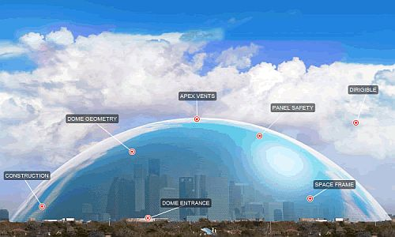

You have been specially chosen to be part of the first colonisation of the moon. The only way to survive is in a dome. YOU are in charge...
HOW WILL YOU SURVIVE IN A DOME FOR TWO YEARS?
Big Question
“What do we need to put into the Dome and why?”
Details:
- The Dome needs to exclude all material from outside except sunlight.
- The Dome will be 2Km in diameter.
- Only healthy people will be allowed to live there. You will decided who and how many will be allowed in the dome. Think about what jobs they would be able to do.

Presentation
You will be presenting you dome idea to the Latimer Space Programme. The presentation will need to include:
- A model of the dome and what is inside.
- A presentation board with all the information that you will have collected over the length of this project.
- A speech to give to Latimer Space Programme team, explaining your decisions, the different features of your dome.

Time:
You have 6 weeks to gather the knowledge you need to be able to decide what goes into your dome and why.
Booklet:
This booklet will help you gather information and design your dome. It includes key ideas you will need to think about to make this dome a success.
After you have completed the task for the week, please make sure you add your findings to the presentation board.
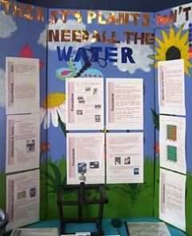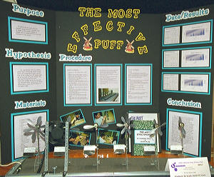
Week 2 TASKS: How do plants grow?
As you go through these task think about what and how you can add to your overall presentation. Please send pictures to your staff on how you are getting on.
Remember the aim of these tasks is to help you with your overall presentation.
TASK 1: If you are going to survive on the moon you are going to have to grow food! That is difficult! Watch this video about growing food on Mars by Nasa – what are the challenges and solutions!
https://www.youtube.com/watch?v=LMKl-KAg07U
Task 2:
The film “The Martian” has some great clips about growing food on another plant and science solutions to problems – if you have not seen it and you have access to it (it’s a 12) then one of your tasks this week could be watching it!
Task 3:
Explain the process of Photosynthesis by drawing a diagram and explaining what is happening. You can use these video to help you, watch it several times and make notes before you try drawing your diagram.
https://www.youtube.com/watch?v=PpuEIQZu6N8 https://www.youtube.com/watch?v=DfbR2IjC80o

What is the word equation for photosynthesis?
__________ + _________ ____________+ ___________

Task 4: Try growing some plants!
You can now try to grow some plants of your own, collect the seeds from tomatoes/peppers/melon/courgette. You can see how to grow them from tomato slices here!
https://www.gardeningknowhow.com/edible/vegetables/tomato/planting-tomato-slices.htm#:~:text=Growing%20tomatoes%20from%20a%20tomato%20slice%20is%20a%20really%20easy,the%20top%20of%20the%20container.
If you can get seeds then a handy guide to growing them is here
What do you need to grow the plants successfully in your new colony on the moon? ............................................................................................................................................................................................................................................................................................................................................................................................................................................................................................................................................................................................................................................................................................................................
What types of plants would you have in your dome? How much space will you need?
............................................................................................................................................................................................................................................................................................................................................................................................................................................................................................................................................................................................................................................................................................................
Track the growth of your plant over the next 4 weeks using the graph paper. You will need to think about the heading for your axis as you plot the growth of them. You could take time lapse photography of them ot try different seeds in different lights.
Conclusion: (what is the best way to grow plants and how do you know)
....................................................................................................................................................................................................................................................................................................................................................................................................................................................................................................................................................................................................................................................................................................................................................................................................... Lightbox activity:
Try the exam questions in the link below. You should then mark the questions and close the gap by adding in any extra information.
Photosynthesis exam questions.rtf Photosynthesis mark scheme.rtf

Art & Design Technology Faculty

Choice of tasks:
Please choose from the following list of tasks. They have been chosen to give you a choice of learning activities.

DT Task 1: INSPIRED BY NATURE!
Description: Look up the ‘origin story’ for Velcro- clue: George De Mestrel’s dog. This is a great example of how designers are often inspired by nature. Design a car or a bicycle that is influenced by nature.
Light Box Challenge: Can you find out how the Hyundai Tiburon is influenced by nature?

DT Task 2: WHO AM I? TARGET MARKETS
Description: Discuss with a family member/ someone you are isolated with, if you can create a diary entry for them called ‘A day in the life of (name)’. Every three hours discuss with them what they have done and write down a record. Ask if they have had problems or struggled with any products, what things they have enjoyed etc…
This is the information that advertising companies use to make or improve products. It is what we do when we get to GCSE in order to design products that help people’s lives.
Light Box: Can you think of a product ‘real or imaginary’ that would benefit this person’s life? For example, they may like to exercise but with the gyms closed some workout dvd’s would help them.

Art Task 1: DRAW!
Description: Complete 3 high quality pencil drawings of 3 things that begin with the same letter as your name…
Light box challenge: Try using different pens to complete your 3 drawings instead!

Art Task 2:
Description: Find an old glass jam jar or container that is being thrown away. Can you decorate the jar by covering the surface by gluing on your own drawings, tissue paper or magazine cut outs?
Light box challenge: Your decorated jar could be turned into a candle holder or lantern- perhaps add a handle?

Art Task 3:
Description: Slinkachu is a street artist. A street artist produces their work in a public space. Slinkcahu is best known for his ‘Little People Project’. In this project he paints miniature figures and then places them in a public place. The figures are left permanently in a public place for visitors and passers-by to find. In response to the work of Slinkachu, create and photograph your own miniature scenes using miniature figures or small toys (Lego people, toy soldiers, Playmobil figures). Remember to take the photographs from a low angle and stay safe, these can be either inside or outside scenes!
Light box challenge: If you do not have access to any figures, be creative and try to create your own small figures from materials at home.
Food Task 1: SEASONAL FOODS
Description: What foods are currently in season in the UK? Plan a 3 course meal using foods that are seasonal during the British Summer!
Light box challenge: Prepare and cook some (or all!) of your menu! Email photos to Mrs Ashcroft…

Food Task 2:
Description: INITIALS CHALLENGE!
Can you design a dish (sweet or savoury) where the MAIN ingredients/flavours begin with the letters of your initials? Mine are M-A so I could make a cake that uses Marzipan and Almonds for flavour, or a Pizza with Mozzarella and Anchovies on top! Draw out your dish and list the ingredients.
Light box challenge: Have a go at making your dish! Email a photo to Mrs Ashcroft

Food Task 3: COMPARE YOUR 2 FAVOURITE SNACKS
Description: Look at the nutritional information on the food packaging. Analyse this information and make a judgement - which is the healthier snack and why?
Light box challenge: Can you justify your answer and make links to the Eatwell Guide and Guideline daily amounts of macro-nutrients and micronutrients?

Business, ICT and Media Faculty

New York Trip Project

Description
Over the next few weeks you are going to plan and create a range of business documents for the New York Trip. Last week you looked at how students can work safely in an ICT environment. You are now going to start looking at the style and colour schemes (house style) you will use for this project.

Business Logo Task 1:

Create a logo that you will use to go on all documents for the New York trip. Think about the shape and size, elements you will include and colours you think will stand out. You could use word or power point to compete this.

Business Documents House style Task 2:

Design a house style that you will use in all your documents (e.g. layout, colours, logo, font styles that you are planning to use). You can fill in the table below or create your own in word to store your information. What colours, sizes, fonts and layout would you use for the documents in the table.

Light box Challenge - Create a business card for the students. You must use your logo and the school name/address on it and follow the house style you planned so that all documents you make will be consistent.
- You should make sure that your card is the appropriate size and includes elements that you discussed in your house style.
- Make sure to include a logo, name, job role and contact (make this up)
- If you have publisher use this and go to inbuilt template and find business cards – you can use a template or design your own.

Humanities Faculty

Task Heading:
This half term you will complete a Humanities challenge:
- ‘Around the world in 30 days’
You have 25 school days left of this year, and so each week we will set you a continent to research and learn about.
Description:
Your task is simple; you will be given a continent each week and you must produce a postcard fact file or a flapbook on each – you may choose to focus on a particular country or groups of countries – it is up to you. If you want to look at an example of one a student made last week click here. Please send in what you have done to us!
- This week you will research EUROPE

- Front page: images of key landmarks from the continent – these can be
natural or manmade
- Second Page: The History of the continent
- Third Page: The Geography of the continent
- Forth Page: The Culture and Beliefs of the continent
WAGOLL:
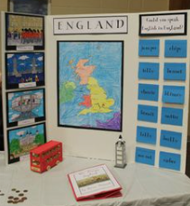
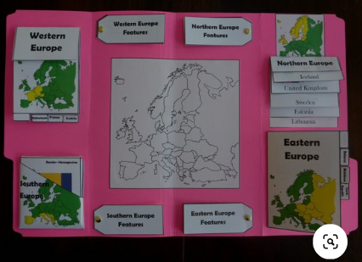
Ideas on what to include:
- Population Size and details about the population
- Maps of the continent and countries
- Climate
- National Landmarks – e.g. longest river, tallest mountains
- Animals who are native
- Religions
- Places of pilgrimage (religious journey’s)
- Religious and traditional customs/festivals/ clothing
- Languages
- Key moments in History
- Explorers
- Ancient civilations
- Major empires who have inhabbitated the continent
- Conflicts

Modern Foreign Languages Faculty

Choice of tasks:

Please complete the Vocab Express task AND choose at least one more from the following list of activities. They have been chosen to give you a choice of learning activities.

Task 1 Vocab Express

Description:

Learn the vocab in the blocks assigned to you this week. You should complete the assignment for at least 10 minutes on 3 different days over the course of the week.

Light box challenge:

Choose at least 5 new words / phrases that you have learnt on the current assignment and write a short paragraph that includes them. Can you also include any Magic 12 structures?

Around the world:
In 1872 Jules Verne published this famous novel in which Phileas Fogg and his valet Passepartout attempted to circumnavigate the world in 80 days. Times have moved on and we reckon that the students at Latimer can do this in fewer than 30!
This half term you will complete a MFL challenge where you will need to tackle tasks from a variety of topic areas in order to earn enough miles to travel around the world, just like the characters in the novel.
The Rules
- Each week, we expect you to earn a minimum of 2000 Miles – This should take about 1 hr. There is no maximum and there is more than enough here to keep you busy!
- All miles totals are halved if you choose a country whose main language is English.
- You need to collect evidence to earn miles!
- Choose something that interests you. Get your family and friends involved and get stuck in!
- ePraise points for anyone who manages to travel a total of 25,000 miles – enough to travel the circumference of the Earth – between now and the end of term.
How to submit your evidence
- Complete a challenge from the list– making sure that you keep some evidence. For different challenges, this could be different things. A video, a photo, a write up, an audio recording, or a screenshot – you can decide.
- Scan the QR code to upload your evidence. Only students in Y7-8 have been sent this and I have to approve new posts. The password is Latimer1. Without the QR code or link below, people are unable to access this area. You can also use this link from your computer or device. https://padlet.com/awest76/MFL80dayschallenge
- Press the little plus sign that appears. The title of your work should be the challenge number and your surname, initial and form group – ie for me: Q1 – WestA W1
- You can then attach your evidence easily.
- If you would rather keep your work private, and don’t want to see what others are adding, you can simply email your evidence to your teacher, but copy me in too (awest@latimer.org.uk). If you are sending a large video file use wetransfer.

Task: To earn your miles you should complete at least 1 task from the weekly themed challenge lists (this week it’s Sports), but you can also complete up to 3 Quick Wins each week. The Quick Wins will remain the same throughout the term so choose wisely!

Sports Challenges

S1 – Research the rules of a game/sport played in a different country online and play it with your family. 2000 Miles + bonus for family involvement

S2- Research an Olympic athlete from another country and create a poster about their life and sporting success.
1000 Miles + bonus for presentation

S3 – Watch the highlights of a sport where the commentary is NOT in English. Record your own English commentary video – try the Ligue 1 or Top 14 coverage on Youtube for ideas.
3000 Miles + bonus for showmanship

S4 – Hold a ‘Question of Sport’ quiz with your family. At least ten questions related to Sports, Teams or Sportspeople from non-English speaking countries.
2000 Miles + bonus miles for showmanship

Quick Wins

Q1 - Secure a time under 20 seconds on ‘Match’ on Quizlet for vocabulary. Click the links to be taken to the relevant Quizlet pages.
Y7 Module 1: https://quizlet.com/366223666/match
Y7 Module 2 : https://quizlet.com/511819874/match
Y8 Module 1: https://quizlet.com/216246230/match
Y8 Module 2: https://quizlet.com/216246273/match
500 Miles.

Q2A – Take part in a Quizlet Live game - follow @LatimerMFL on Twitter or check your school email at the start of the week for times. The link to join the game will be emailed to you on the day.
500 Miles

Q2B – Win a Quizlet Live game.
1000 Miles

Q3 – Learn some vocab on Vocab Express on 5 different days in a week for at least 10 minutes each time.
1000 Miles

Q4 – Learn to count to ten in a different language - NOT French.
1000 Miles

Q5 – Complete 1 song on www.lyricstraining.com in French.
500 Miles

Q6 – Learn how to write a phrase in a language that uses a different script, like Arabic or Mandarin.
1000 Miles

Q7 – Change your phone into French for 24 hours.
500 Miles

Q8 – Find out which language other than English would be most useful for your dream job.
500 Miles

Q9 – Use the Duolingo app to practise French for a 3 day streak.
1000 Miles

Q10 – Find 10 brand names from France that we buy here – for example Chanel is from France.
1000 Miles

Bon courage!

Ignite

These tasks are for those students in Year 7 and 8 who do not do French

Choice of tasks:
Please choose from the following list of tasks. They have been chosen to give you a choice of learning activities.
Reading and Spelling: IDL Cloud
Description:
Log onto your IDL account (https://idlsgroup.com/ remember this is best accessed via Google Chrome and you will need headphones but not access to a webcam/ microphone) using your usual username and password. Remember that this is case sensitive and you need a capital letter for your initials in this format:
Username: FirstinitialSurname followed by @nn156sw
Password: Surname followed by 123
We recommend you spend a minimum of 20 minutes on IDL Cloud three times per week. Don’t forget to then read your Accelerated Reader book for 20 minutes per day and quiz where you can on the usual AR site.
Light box challenge:
Practice your touch typing. Open a blank Word document and write a paragraph about your week so far. You could time how long it takes you to write a certain amount of words and then see if you can beat this challenge next week! The more familiar you get with where the keys are on the keyboard, the faster you will be at typing responses, which helps you in an assessment.
Spelling: Look, Cover, Write, Check
Description:
Look, Cover, Write, Check is a spelling strategy used to help you learn to spell tricky words. This online spelling game: http://www.ictgames.com/mobilePage/lcwc/index.html allows you to select some tricky words (although these are categorised into Primary year groups, the tricky words are very tricky and definitely appropriate for you to revisit, particularly the tricky lists in Years 3,4 and 5 and 6!).
- You look at the word
- The game covers it over
- You type the spelling
- The game uncovers the spelling to check if you have got it right

Light box challenge:
If you have words which you know you frequently spell incorrectly, you can enter them here in Spelling City and focus on getting these right in a variety of ways: https://www.spellingcity.com/ Enter four words of your choice and select which activity you would like to do to focus on the spelling strategies for that particular word.

Performing Arts Faculty

Dance: Africa - Week 2
During this half term, you will be exploring dance styles from around the world. This week we are in Africa. You could use the information from your Humanities project from last week to help you understand this work.
- Watch this YouTube Clip of people performing different African dance moves and styles. https://www.youtube.com/watch?v=iVwsJka2pxg
- Lion King is currently rated the top stage musical at the moment. Lion King is set in the fictional location of the Pride Lands which is loosely based on Kenya and Tanzania in Africa. Learn this ‘He Lives in You’ dance routine from Lion King. https://www.youtube.com/watch?v=Avf5QyUY1Bo
- Answer the questions
Questions:
- What was you favourite dance move/style from the African dance moves and styles YouTube Clip?
CHALLENGE QUESTION: Why? (2 Marks)
- How would you describe the ‘He Lives in You’ dance phrase?
CHALLENGE QUESTION - Use action names, dynamics and space within your answer. (3 marks)
- What performance skills (e.g. strength, alignment) do you think is important when performing the ‘He Lives in You’ dance phrase?
CHALLENGE QUESTION Why? (Give examples in your answers). (3 Marks)
Drama: Week 2
What can you remember from last lesson?
Take a minute to think
- How can we change a piece of text and create different interpretations?
- Why do we try to find different interpretations?
- Fill in the blanks and find as many different ways as you can to interpret the sentences below. Say the sentences aloud and if possible record and listen back to them.
- You can’t be serious, I saw you with my xxxxxxx in broad daylight!
- Every time you put the xxxxxxx there instead xxxxxx it drives me crazy.
- You said you didn’t want to go to the xxxxxxxxxx, why are you so xxxxxxx

- Develop the script below, fill in the blanks with your own words and interpret the meaning
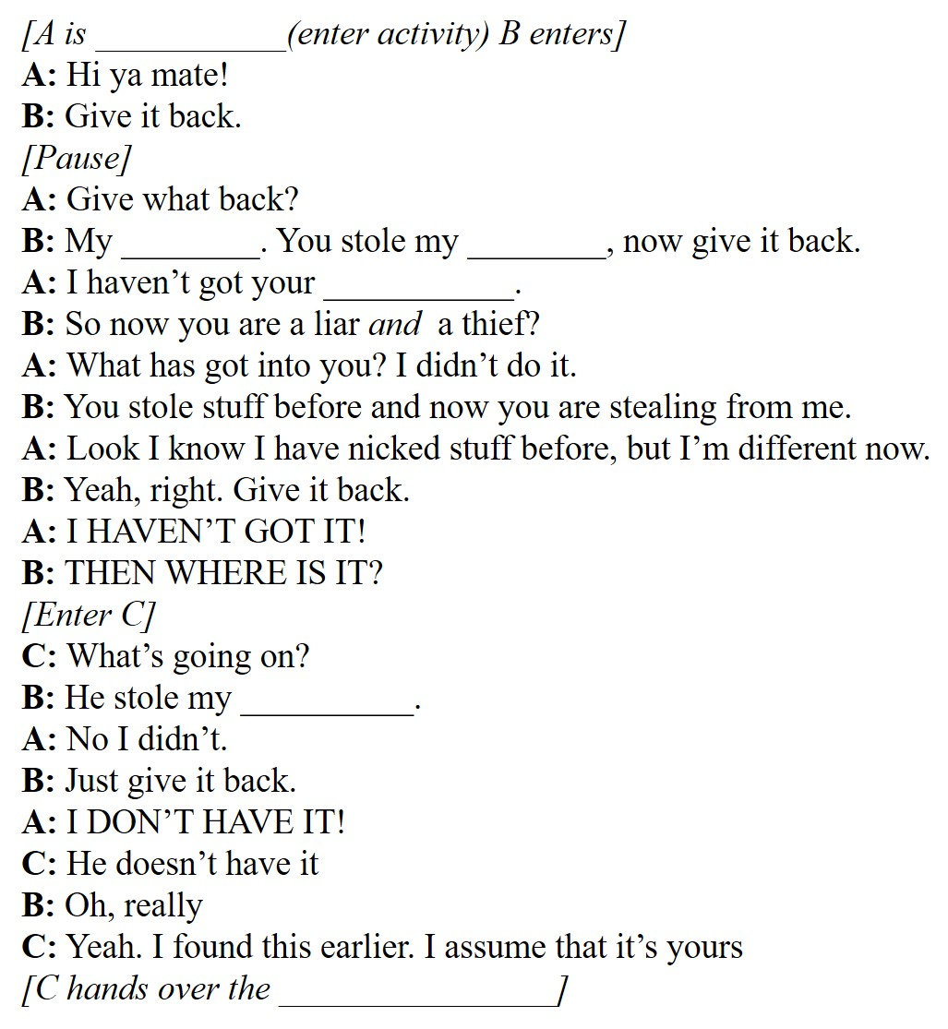
You must consider:
- Personality and mood of the characters
- Place and atmosphere
- Relationships between characters
- Use of stage directions
- DO NOT just try this one way and be satisfied-experimentation is key

Develop the script further by choosing your favourite/most appropriate version and writing a further 20 lines of script.

Music: Week 2
During this half term, you will be exploring descriptive music – music that helps to describe things. These things could be mood, time, story, place, character, anything! Descriptive music has been composed across musical periods and styles, and we are going to look most at FILM music.
Film Music is often known as a score. This is the music we hear as the movie takes place. It can happen when the actors speak, it can happen during a fight scene or a romantic scene. This type of music can creep in so gently, you might not even notice it, but it can also be the most intense part of the film. Think about any scary films you’ve watched... The music tells you when you need to be scared or when you might want to hide your eyes!
When we talk about Film Music, it does not mean the ‘songs’ (pieces of music that are sung) that are in the movie. Most songs we hear in films would have been released before, or around the same time as the movie. They are rarely written specifically for the film, unlike the score which would have been written to suit the atmosphere of every scene, exactly. Songs in movies would be part of the soundtrack.
Task 1: Mark your Listening task from last week, then listen back to try and hear what you missed. Here are the answers to the questions:
1. What difference did the music make on the mood of the scene? Made it seem scarier, more tense, menacing (and other adjectives!)
2. How many notes were used in the melody of the music? 3 different notes or pitches, with 2 of them repeated a lot.
3. How would you describe the pitch? How does this affect the mood? Low. Your opinion is correct!
4. What instruments were playing the music? Low String instruments, Cello and Double Bass
5. What happened to the DYNAMICS of the music as the shark approached and then swam off? Gradually got louder (Crescendo) as the shark approached, and gradually quieter as the shark swam away (Diminuendo).
LIGHTBOX: List the 4 other musical elements, and describe each as you hear them.
Structure – only 1 section
Texture – just 1 layer – thin or monophonic
Duration – short notes, Quavers. See the theme below.
Tempo – Same speed throughout, quite fast. Allegro.

Remember to listen back to the audio to try and hear what you missed. This two note, low pitched musical idea is the shark’s Leitmotif.
A leitmotif is a recurring musical idea (a melody, chords, rhythm or a combination of these) which is associated with a particular idea, character or place.

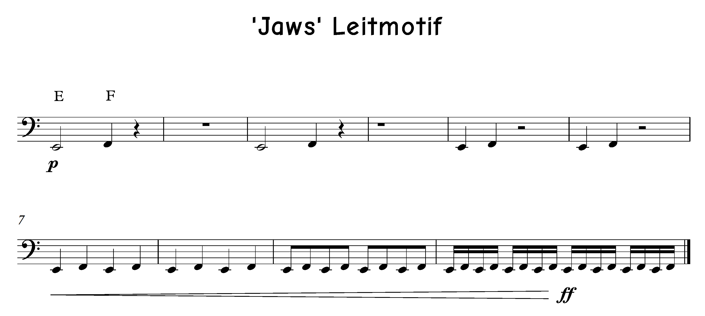

Task 2: Choose a character from a film, and plan out a Leitmotif for them. This is YOUR OWN musical idea that represents them! An example:
MY version of Thanos (a bad guy from the Marvel Universe) would have low pitches, loud dynamics, use drum kit and low brass instruments like trombone and tuba and bass, a thick texture, and lots of long notes at a fast tempo.
Use the table below to help organise your ideas and make some decisions. Remember this is YOUR version of the music for a character to best represent who they are.
Character choice: __________________ from the film _______________________.
Element and meaning | Your decisions | LIGHTBOX – how should this change over time? | LIGHTBOX – WHICH actual pitches and rhythms, tempo etc?
Dynamics: loud or quiet
Duration: long or short notes
Pitch: high or low
Timbre: unique sounds of an instrument or voice
Tempo: fast or slow
Texture: the number of parts at a time, how thick or thin
Structure: sections

Physical Education Faculty

Task Heading:
This half term you will complete a P.E challenge that involves planning, promoting and running an event:
‘The backyard sports day’

Description:
It’s decision making time! Using your ideas from last week it is time to finalise your plan for your event.

Task: Plan your event in detail to ensure the even runs smootly.
Some descisions that need to be made:
- What date will you run the event?
- What events have you chosen to do?
- Are the events all safe to do?
- What order will you do the events in?
- What time will you start? Finish? Make sure you allow enough time to complete all events.
- Who will be taking part in your event?
- What equipment is needed for each event?
- Will you have refreshements?
- How will you record the scores/times for the events?
- Will you have awards?

Create a template to record all your information in that could then be used for any future event that you organise.

