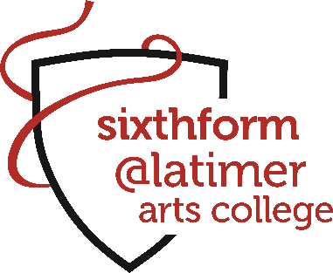

Curriculum Offer 2026

Students are required to choose three subjects to study.
All subject preferences and courses are provisional. Courses will only run where student numbers are sufficient.

Block A | Block B | Block C | Block D
Biology | Chemistry | History | Art & Design
English Language | French | Maths | Music
English Literature | Politics | Product Design | PE
Geography | Sociology | Psychology | Philosophy & Ethics
Performing Arts (BTEC) | Creative Digital Media (BTEC) | Business (BTEC) | Physics
Single Award Sport (BTEC) | Information Technology (BTEC) | Health & Social Care (BTEC) | Criminology (Applied)
 |  |  | Double Award Sport (BTEC)
Further Maths will be available as an additional option for students achieving Grade 8 at GCSE Maths.
The Extended Project Qualification (EPQ) will also be an additional option for students meeting requirements, as part of our extended curriculum offer.
We will consider applications for 4 A levels for students with exceptional academic ability on an individual basis.
Wherever possible we will try to accommodate subject requests but cannot guarantee this. If you desire a subject combination that is not possible above, please indicate this on your application.

